Setting up Jupyter Notebook

Mac:

Anaconda:

Installation:

1. Use link below to download ‘Anaconda’ Mac executable. ‘Download’ under ‘Anaconda Distribution’

<https://www.anaconda.com/products/distribution#macos>

1. Click on executable file ‘Anaconda3-2022.10-MacOSX-x86_64.pkg’
2. Proceed through dialog box to install.
3. Finder -> Applications -> Anaconda Navigator. That will open new window
4. Under ‘Jupyter Notebook’ select ‘Launch’ to open.

System:

1. Install newest version of python3 using link below. Download ‘macOS 64-bit universal2 installer’ underneath ‘Files’ section. This will send executable file to ‘Downloads’ folder

<https://www.python.org/downloads/release/python-3111/>

1. Click on file ‘Python-3.11.1-macos11.pkg’. This will start python installation. Proceed through dialog box options.
2. Open mac ‘terminal’. Finder -> Applications -> Utilities -> Terminal
3. Run following commands to confirm installed correctly. Should print version of both applications.

python3 --version

pip3 --version

1. Install jupyter notebook using pip3 command below.

pip3 install jupyter

1. In terminal type following to launch jupyter notebook in default browser.

python3 -m notebook

Windows:

Anaconda:

Installation:

1. Use link below to download Anaconda executable. ‘Download’ underneath ‘Anaconda Distribution’

<https://www.anaconda.com/products/distribution#windows>

1. This will download file ‘Anaconda3-2022.10-Windows-x86_64.exe’ to your ‘Downloads’ folder
2. Double click on file ‘Anaconda3-2022.10-Windows-x86_64.exe’ from above step.
3. Proceed through dialog box options to install.
4. Open start menu, expand ‘Anaconda3’ -> ‘Jupyter Notebook (Anaconda3)’. Selecting this will open jupyter notebook in default web browser. Make sure default web browser is Google Chrome, Microsoft Edge or Firefox.

[Written Instructions](https://www.geeksforgeeks.org/how-to-install-anaconda-on-windows/)

System:

1. Install python for windows using link below. Click ‘Download Python 3.11.1’ to download executable file ‘python-3.11.1-amd64.exe’.

<https://www.python.org/downloads/>

1. In Downloads folder double click on ‘python-3.11.1-amd64.exe’. Proceed through dialog box options. Make sure to select option ‘Add python.exe to PATH’
2. Once complete open command prompt. Start menu -> cmd -> command prompt
3. Type following ‘python3 -m pip install jupyter’
4. Launch jupyter notebook with following command. This will open jupyter notebook in default web browser.

jupyter notebook

Using Jupyter Notebook:

1. ‘New’ -> ‘Python 3’ to create new jupyter notebook file. ‘Upload’ to import an existing jupyter notebook file.
2. Description: Jupyter provides a web-based interactive computing platform where we can use code, narrative text, equations and visualizations. It will allow us to practice python programming. Throughout a notebook, you will see cells starting with ‘In [ ]:’
3. You can write code inside a cell by clicking inside the box to select it. When we write code in it, we can run it by clicking the run button on the top that looks like a play button or keyboard shortcut Shift + Enter.

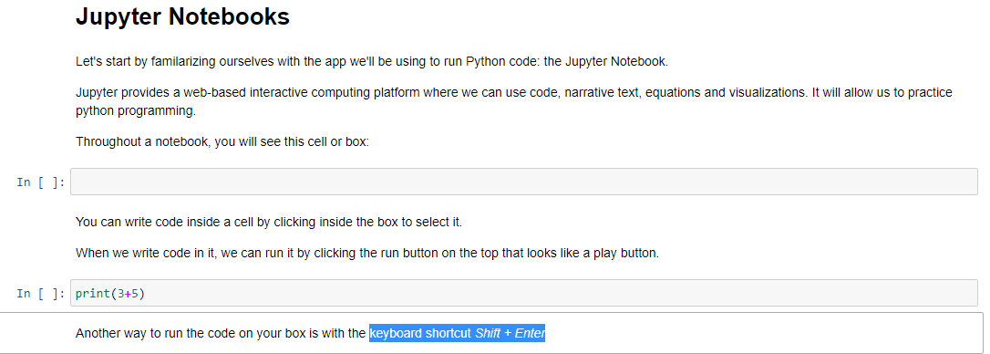

Installing Python Packages to Jupyter Notebook session:

Mac:

1. Open terminal. Finder -> Utilities -> Terminal
2. Depending on which installation method you performed above will determine how to install packages.

Anaconda:

conda install ‘package_name’

ex: conda install pandas

System:

pip3 install ‘package_name’

ex: pip3 install pandas

Windows:

1. Depending on which installation method you performed above will determine how to install packages.
2. Open command prompt. Start menu -> cmd -> command prompt

Anaconda:

conda install ‘package_name’

ex: conda install pandas

System:

pip3 install ‘package_name’

ex: pip3 install pandas

Saving Jupyter Notebooks

1. Jupyter notebook open.
2. ‘New’ -> ‘Python 3’ to create new jupyter notebook file. ‘Upload’ to import an existing jupyter notebook file.
3. File -> Save as -> provide name for new file. This will be stored and visible in menu every time you open jupyter notebook moving forward.
4. File -> Download as -> download variety of different programming files(notebook, python)